Basic Bioinformatics (BE304)

## Lab Assignment 6

## Total Marks: 40

* 1. Open the Expasy home page (<https://www.expasy.org/>)
  2. Goto ‘UniProtKB/Swiss-Prot’ module.
  3. Click on the ‘Browse the resource’ button.
  4. Enter the accession number: “Q15465”
  5. Which protein did you find?

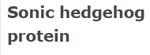

* 1. Which database holds the above entry; TrEMBL or Swiss-Port?

Ans. Swiss-Port

* 1. Report the subcellular location of the protein.

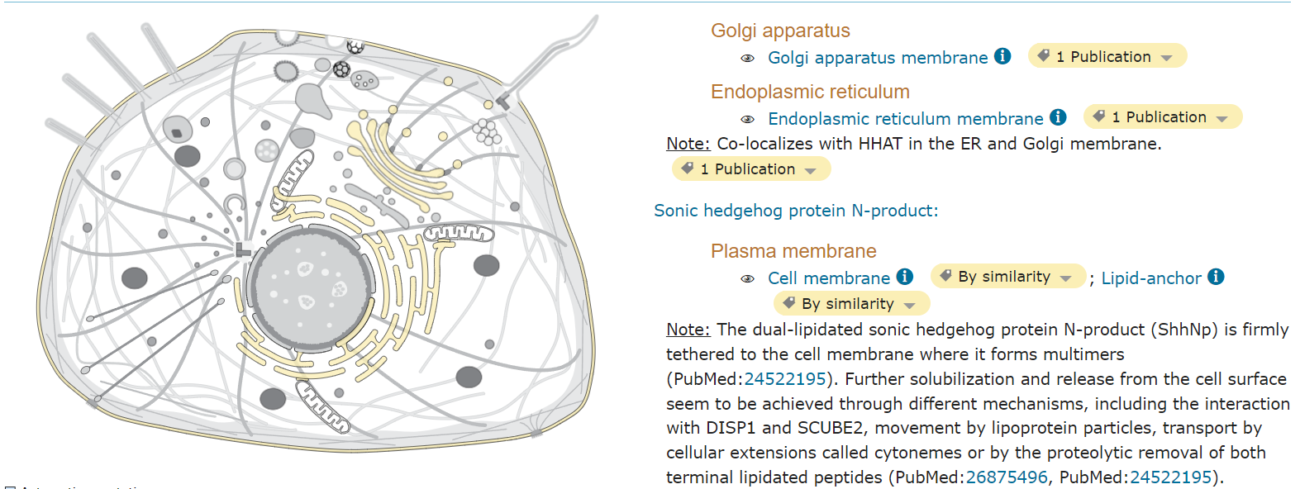

* 1. Download the fasta sequence of the given protein.

**(5)**

* 1. Open the Expasy home page (<https://www.expasy.org/>)
  2. Goto ‘SWISS-MODEL’ module.
  3. Click on the ‘Browse the resource’ button.
  4. Click on ‘Start modelling’.
  5. Upload the fasta file from the previous exercise.
  6. Click on ‘Build model’
  7. Mention the number of templates you found for the sequence.



* 1. How many protein models are available for the given sequence?

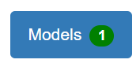

* 1. Download the protein model in the ‘Spacefill’ configuration.

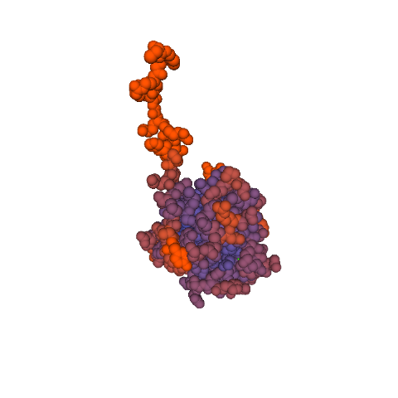

**(5)**

* 1. Open the Expasy home page (<https://www.expasy.org/>)
  2. Goto ‘STRING’ module.
  3. Click on the ‘Protein by sequence’ option.
  4. Paste the amino acid sequence of SHH protein from exercise 1
  5. Click on the search button

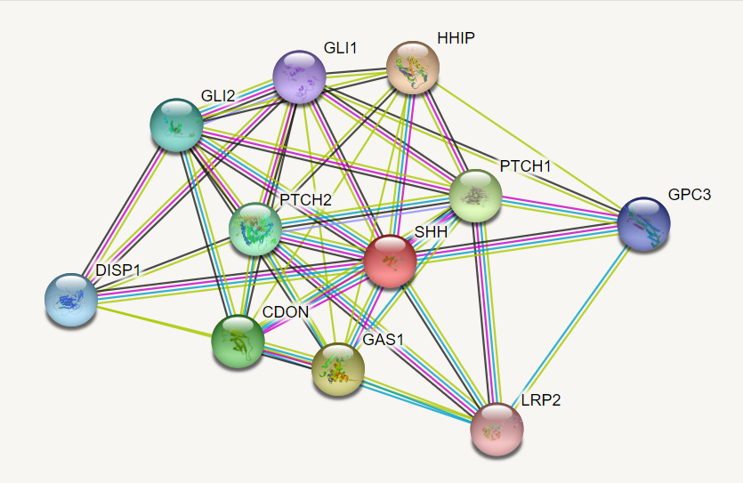

* 1. How many interacting protein partners are found for SHH?
  2. Mention the name of interacting proteins and their nature of interaction with SHH.

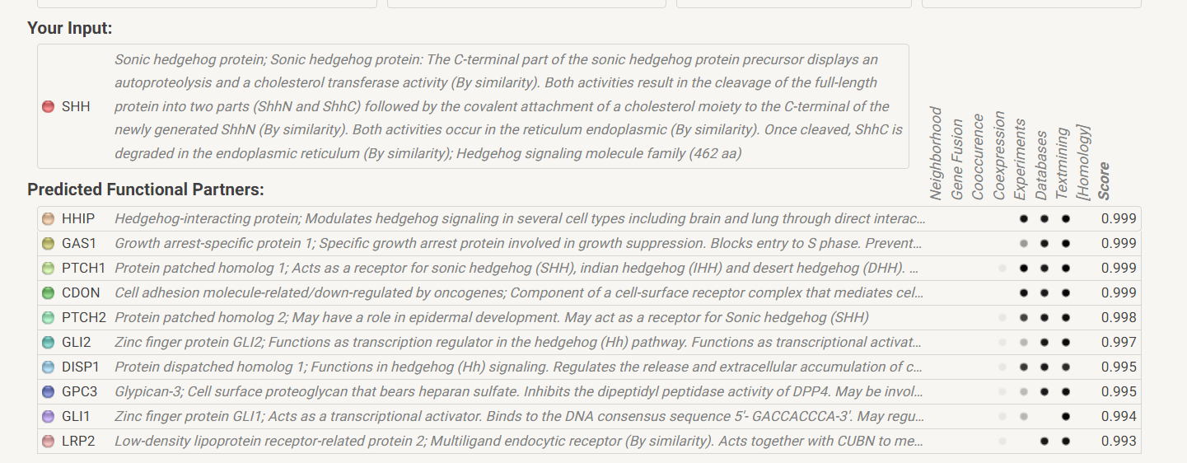

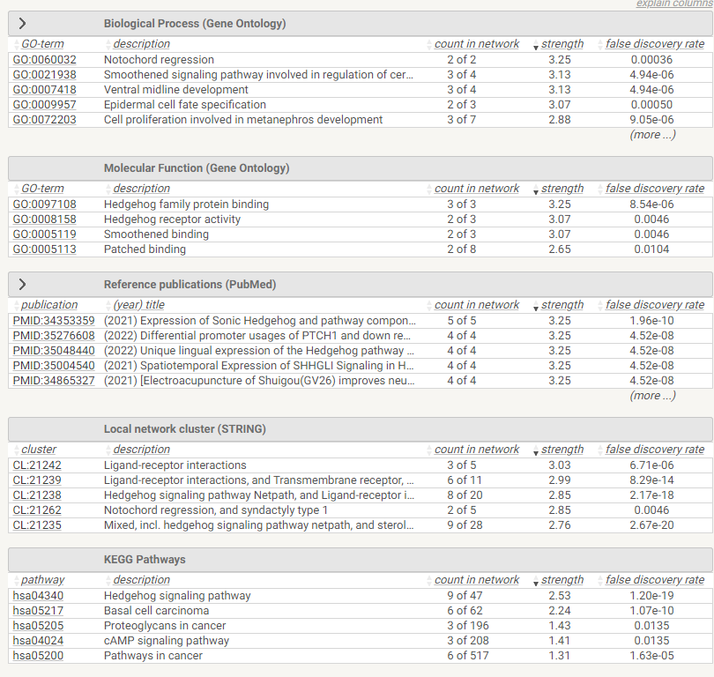

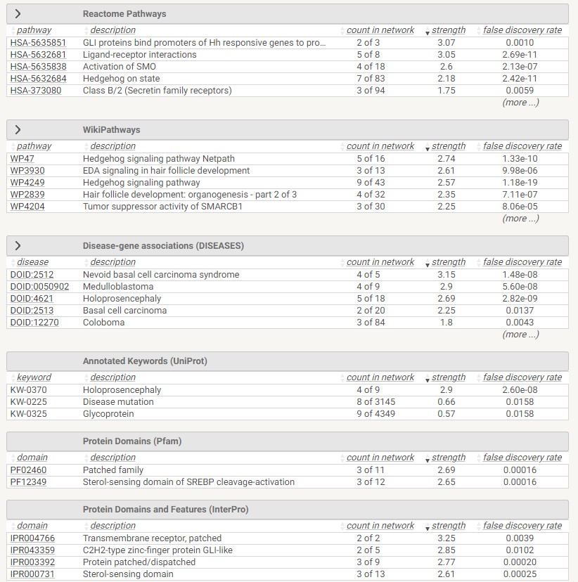

* 1. Mention the number of nodes and edges present in the network



* 1. Download the interaction network.

**(5)**

* 1. Open the following link <https://www.ebi.ac.uk/interpro/>
  2. Upload the downloaded protein sequence.
  3. Mention the different type of domains found in the sequence.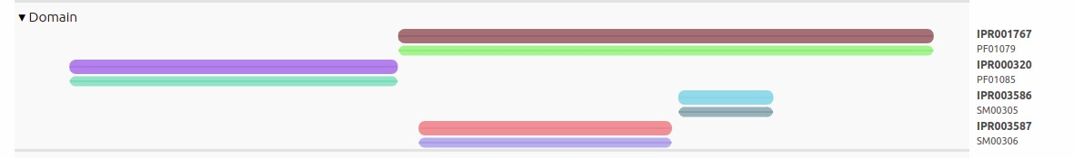
  4. List out the biological process predicted for this protein.

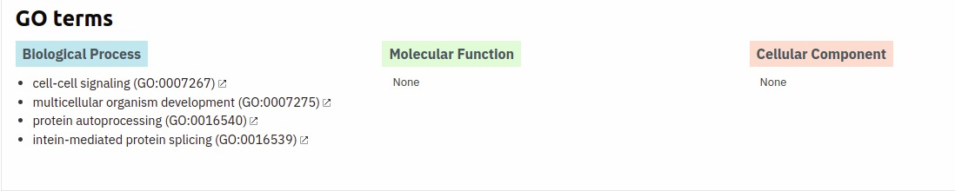

**(5)**

* 1. Open the Expasy home page (<https://www.expasy.org/>)
  2. Goto ‘SwissOrthology’ module.
  3. Enter the accession number: Q15465.
  4. Select SHH orthologs at the ‘Primate’ taxonomic level.
  5. Download the ortholog sequences from the OMA database.

**(5)**

* 1. Open the services page of EBI (<https://www.ebi.ac.uk/services>).
  2. Select ‘Clustal Omega’.
  3. Use the orthologous sequence file from the previous exercise.
  4. Click on submit button.
  5. Download the multiple sequence alignment file.
  6. Visualize the evolutionary relationship between the given sequences.

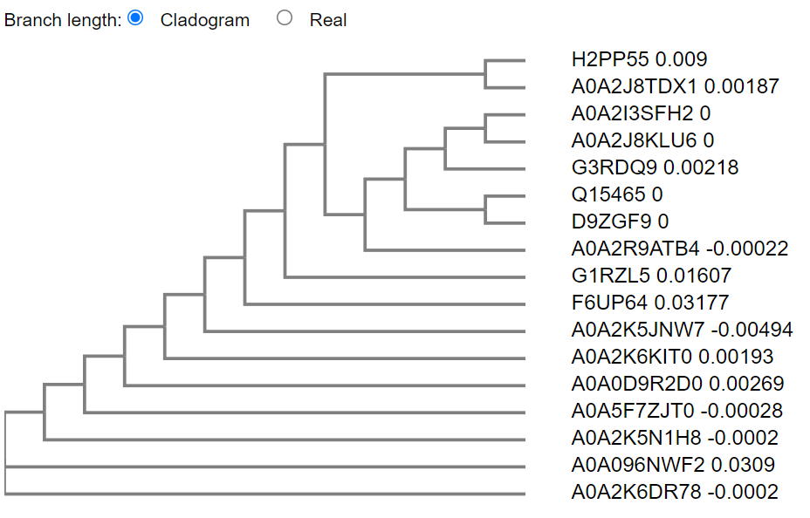

**(5)**

* 1. Open the following link <https://www.ebi.ac.uk/Tools/sfc/>.
  2. Launch ‘Seqret (EMBOSS)’.
  3. Convert the orthology fasta file into ‘Phylip’ format

**(5)**

* 1. Open the MGI home page (<http://www.informatics.jax.org/>)
  2. Click on the ‘Human - Mouse: Disease Connection’ module.
  3. Select the ‘Disease or Phenotype Name’ field from the options.
  4. Enter “diabetes mellitus” in the search box.
  5. Mention the number of genes associated with the disease.

Ans 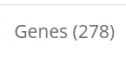

* 1. Explore the heatmap representing human genes correlated to phenotypes/diseases associated with mouse models.

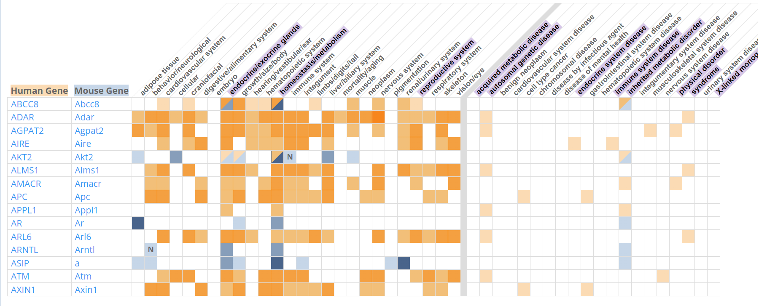

**(5)**